LAB No. 6
Implementation of Deep Neural Network
In this lab, students will study and implement a Deep Neural Network (DNN) for classification tasks. A DNN is an extension of Artificial Neural Networks that contains multiple hidden layers, enabling the model to learn complex and hierarchical patterns from data. Students will begin with a simple DNN on a small dataset to understand its structure and training process, and then apply DNN models to real-world datasets such as Iris and MNIST. Model performance will be evaluated using accuracy metrics.
Introduction
A Deep Neural Network (DNN) is a neural network with more than one hidden layer between the input and output layers. Each layer extracts increasingly complex features from the data. DNNs use backpropagation and gradient descent–based optimizers to update weights and minimize loss.
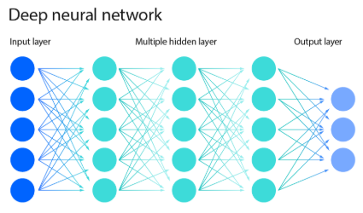
Key Components of DNN:
- Input Layer – receives raw data
- Multiple Hidden Layers – perform deep feature learning
- Output Layer – produces final prediction
- Activation Functions – ReLU, Sigmoid, Softmax
- Loss Function – measures prediction error
- Optimizer – Adam, SGD

DNNs are widely used in applications such as image recognition, speech processing, recommendation systems, and natural language processing.
Solved Examples
Example 1
Build a Deep Neural Network to predict whether a student passes or fails based on study hours and attendance (Small Dataset)
import pandas as pd
from sklearn.preprocessing import LabelEncoder
from tensorflow.keras.models import Sequential
from tensorflow.keras.layers import Dense

# Dataset
data = {
'StudyHours': ['Low', 'High', 'High', 'Low', 'High'],
'Attendance': ['Poor', 'Good', 'Poor', 'Good', 'Good'],
'Result': ['Fail', 'Pass', 'Pass', 'Fail', 'Pass']
}

df = pd.DataFrame(data)

# Encode categorical data
encoder = LabelEncoder()
for col in df.columns:
df[col] = encoder.fit_transform(df[col])

X = df[['StudyHours', 'Attendance']].values
y = df['Result'].values

# Build DNN
model = Sequential()
model.add(Dense(8, activation='relu', input_shape=(2,)))
model.add(Dense(6, activation='relu'))
model.add(Dense(4, activation='relu'))
model.add(Dense(1, activation='sigmoid'))

# Compile and train
model.compile(optimizer='adam', loss='binary_crossentropy', metrics=['accuracy'])
model.fit(X, y, epochs=150, verbose=0)

# Prediction
prediction = model.predict([[1, 1]])
print("Predicted Result (Pass=1, Fail=0):", int(prediction[0][0] > 0.5))

The multiple hidden layers enable the DNN to learn deeper patterns compared to a shallow ANN
Example 2:
Apply a Deep Neural Network to classify Iris flowers into three species.
Solution:
from sklearn.datasets import load_iris
from sklearn.model_selection import train_test_split
from tensorflow.keras.utils import to_categorical

# Load dataset
iris = load_iris()
X = iris.data
y = iris.target

# One-hot encoding
y = to_categorical(y)

# Train-test split
X_train, X_test, y_train, y_test = train_test_split(
X, y, test_size=0.3, random_state=42
)

# Build DNN
model = Sequential()
model.add(Dense(16, activation='relu', input_shape=(4,)))
model.add(Dense(12, activation='relu'))
model.add(Dense(8, activation='relu'))
model.add(Dense(3, activation='softmax'))

# Compile and train
model.compile(optimizer='adam', loss='categorical_crossentropy', metrics=['accuracy'])
model.fit(X_train, y_train, epochs=150, verbose=0)

# Evaluate
loss, accuracy = model.evaluate(X_test, y_test, verbose=0)
print("Test Accuracy:", accuracy)

The deeper architecture improves feature representation and classification accuracy.
Example 3:
Use a Deep Neural Network to classify handwritten digits (0–9).
Solution:
from tensorflow.keras.datasets import mnist
from tensorflow.keras.utils import to_categorical

# Load MNIST dataset
(X_train, y_train), (X_test, y_test) = mnist.load_data()

# Preprocessing
X_train = X_train.reshape(-1, 28*28) / 255.0
X_test = X_test.reshape(-1, 28*28) / 255.0

# One-hot encode labels
y_train = to_categorical(y_train)
y_test = to_categorical(y_test)

# Build DNN
model = Sequential()
model.add(Dense(256, activation='relu', input_shape=(784,)))
model.add(Dense(128, activation='relu'))
model.add(Dense(64, activation='relu'))
model.add(Dense(10, activation='softmax'))

# Compile and train
model.compile(optimizer='adam', loss='categorical_crossentropy', metrics=['accuracy'])
model.fit(X_train, y_train, epochs=10, batch_size=128, verbose=1)

# Evaluate
loss, accuracy = model.evaluate(X_test, y_test)
print("Test Accuracy:", accuracy)

DNN learns hierarchical pixel features and achieves good accuracy, though CNNs are more suitable for image data.

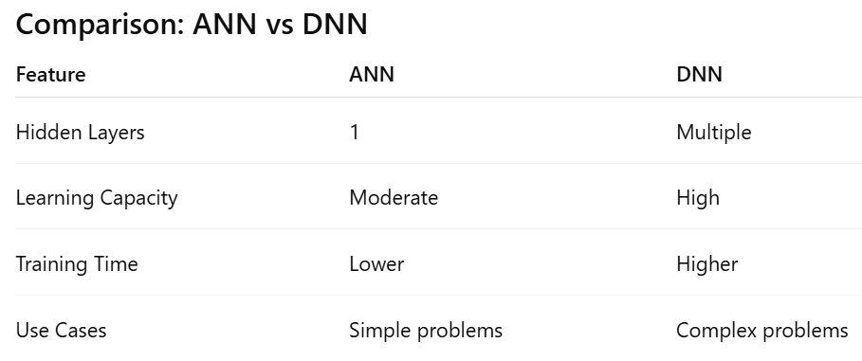

LAB Assignment No 6
Practice Question 1:
DNN Architecture Design
Create a Deep Neural Network to predict whether a student passes or fails using features such as study hours and attendance.
- Use at least three hidden layers
- Experiment with different numbers of neurons
- Compare the accuracy with a shallow ANN (one hidden layer)

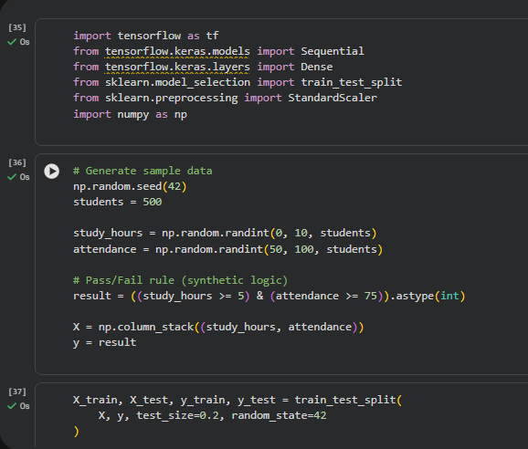
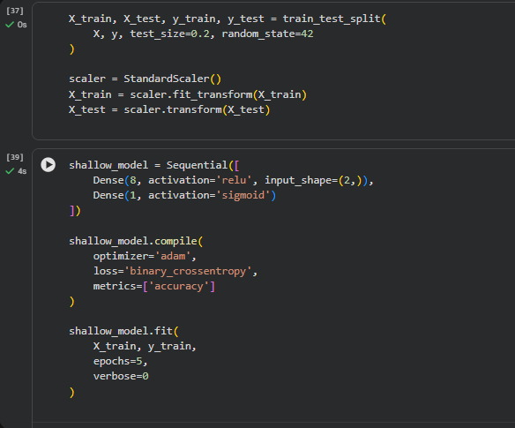
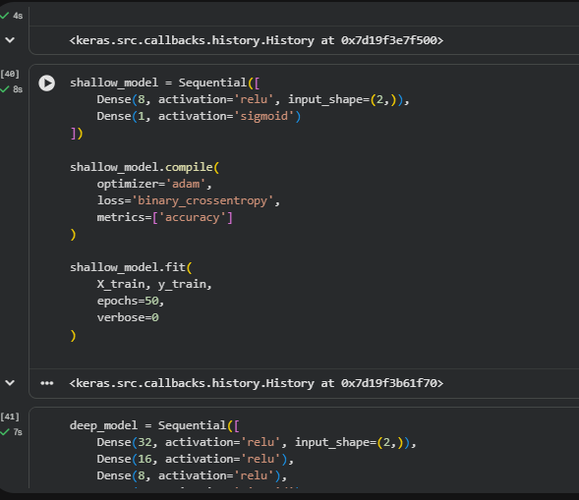
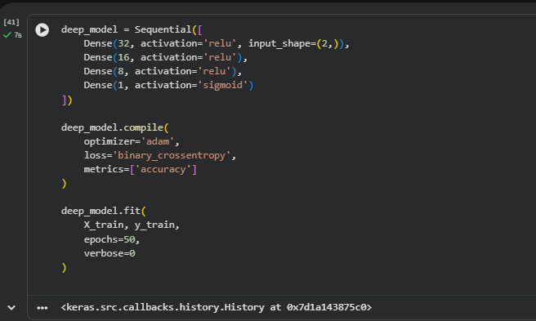
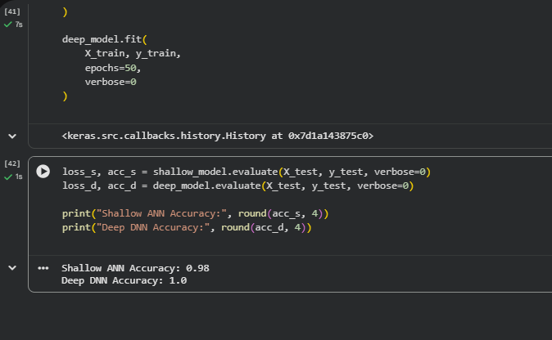
Practice Question 2:
Activation Function Analysis
Using the Iris dataset, build two DNN models:
- Model A: Use ReLU activation in all hidden layers
- Model B: Use tanh activation in all hidden layers
Train both models and compare their accuracy and training behavior. Write your observation.
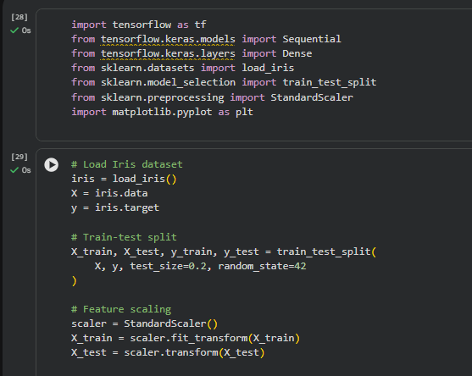

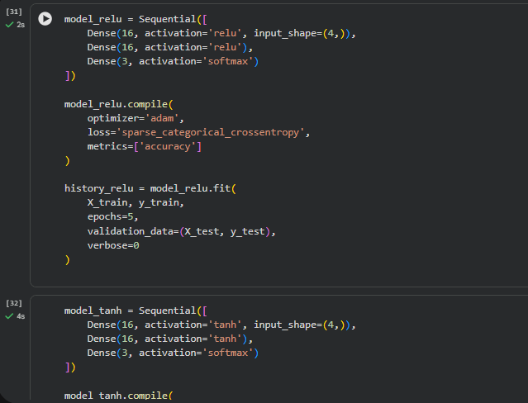
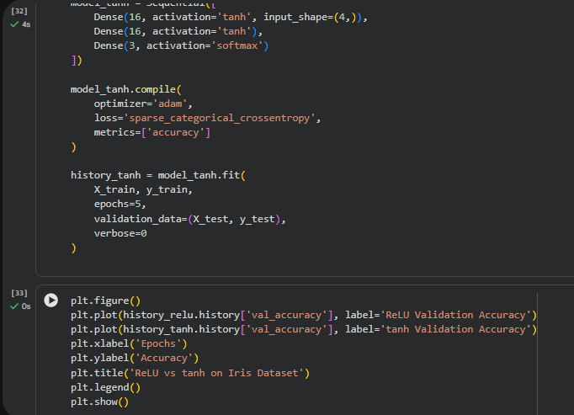
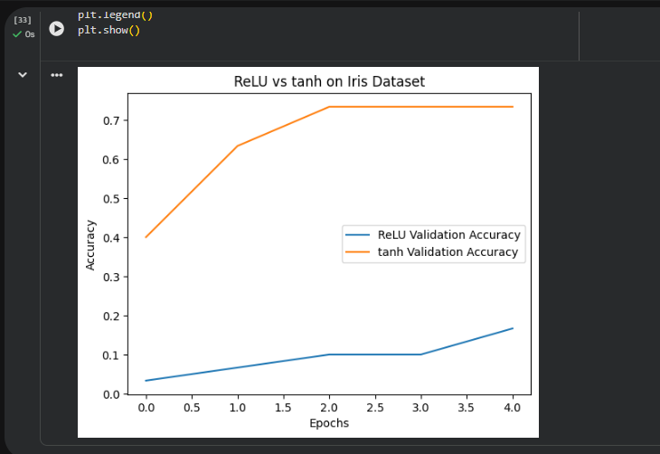
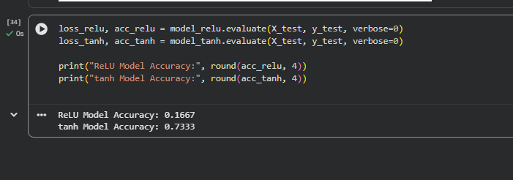
Practice Question 3:
Hyperparameter Tuning in DNN
Train a DNN on the MNIST dataset by changing:
- Number of hidden layers
- Number of neurons per layer
- Batch size
Record how these changes affect training time and accuracy
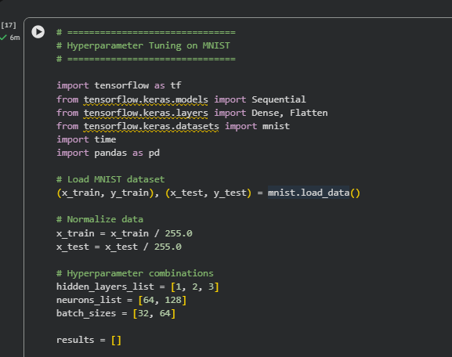

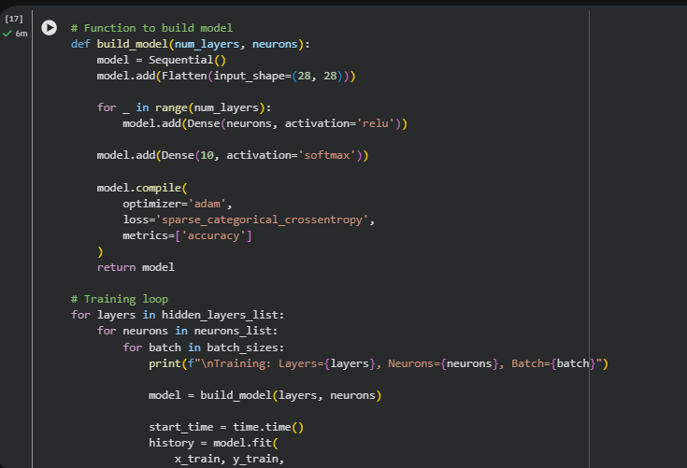
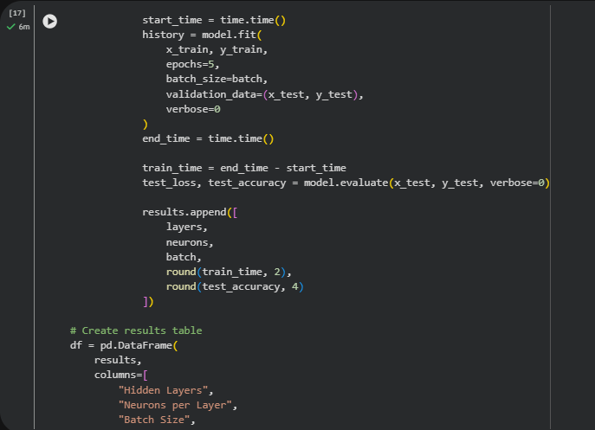
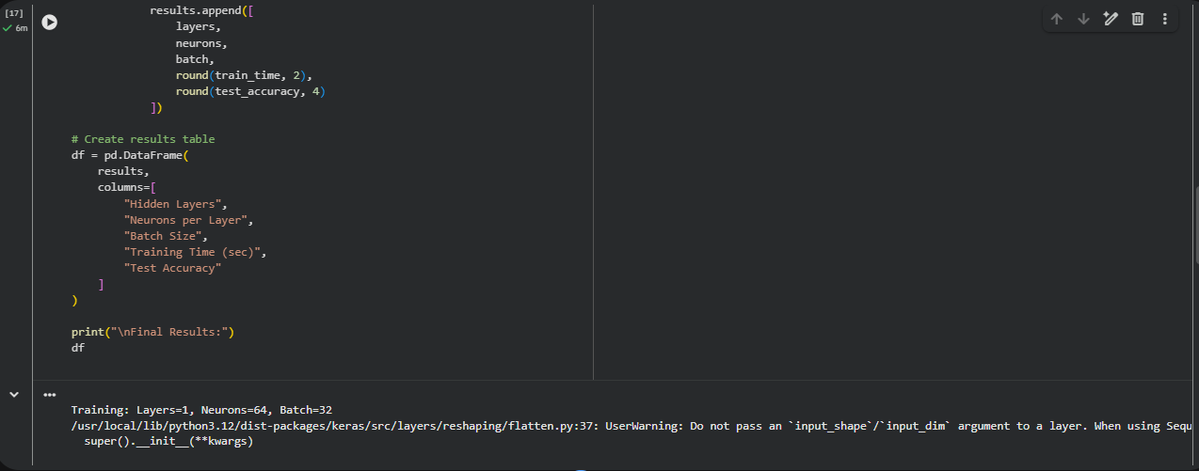
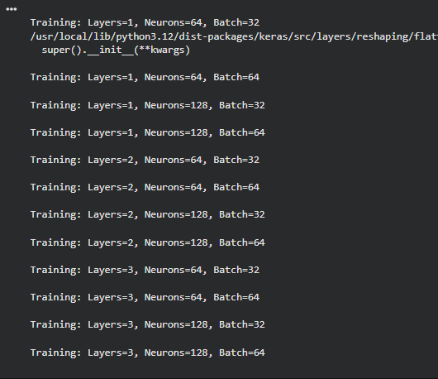
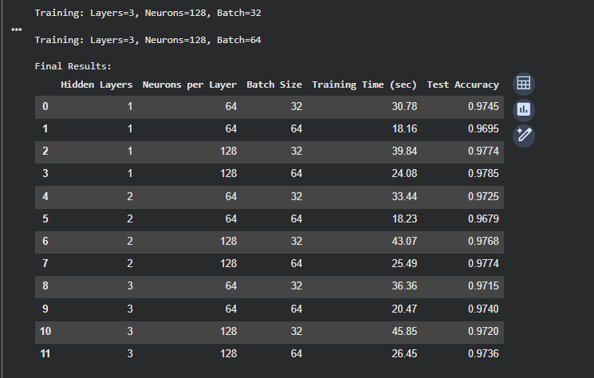
Practice Question 4:

Overfitting and Regularization
Build a deep neural network on any classification dataset and:
- Observe signs of overfitting
- Apply at least one regularization technique (Dropout or Early Stopping)
- Compare model performance before and after regularization
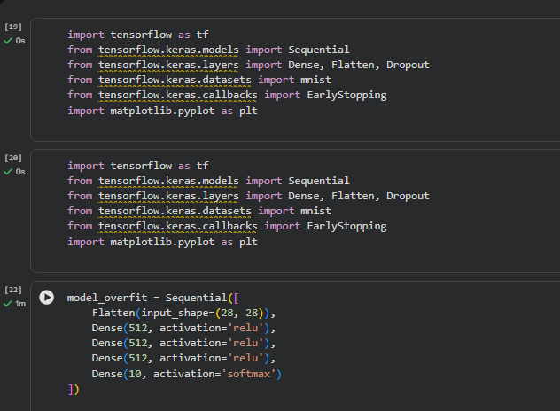
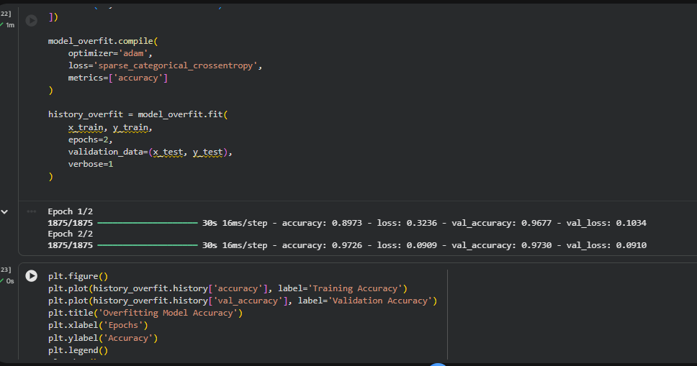
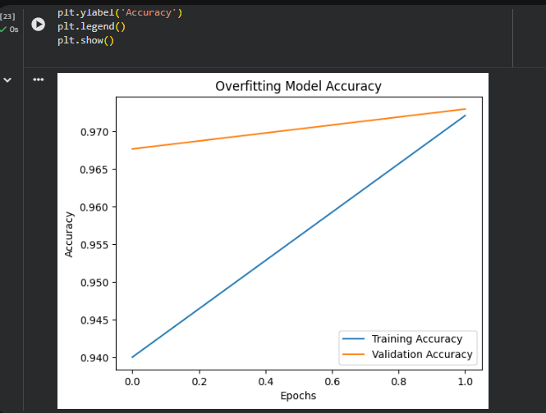
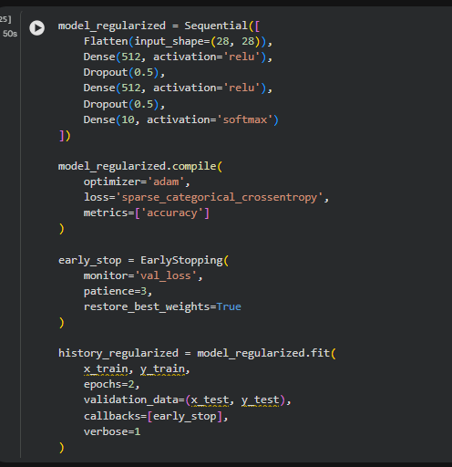
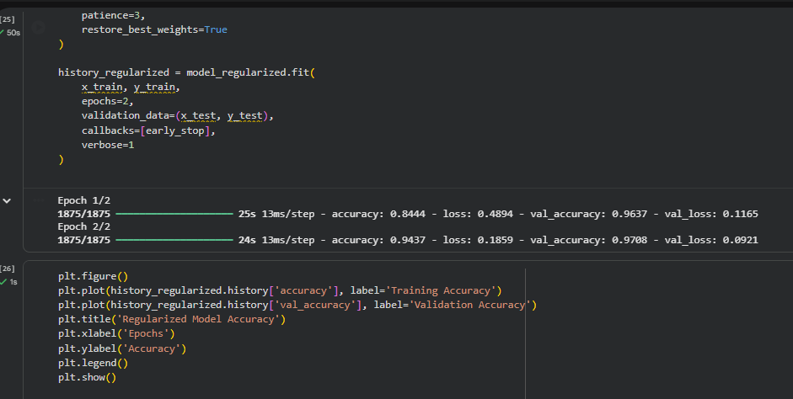
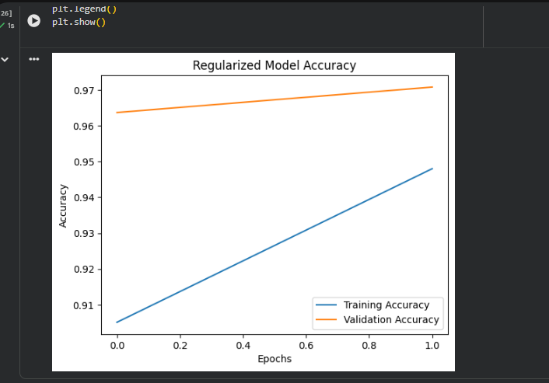
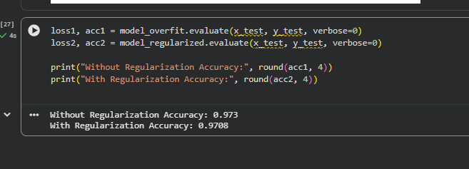

LAB Assessment

Student Name |  | LAB Rubrics | CLO3 , P5, PLO5
Student Name |  | Total Marks | 10
Registration No |  | Obtained Marks
Registration No |  | Teacher Name | Dr. Syed M Hamedoon
Date |  | Signature

